Pair in C++

In the realm of C++, the concept of "pair" proves to be useful when there is a relationship between two values that may belong to different data types.
To illustrate, imagine having two buckets, one filled with fruits and vegetables, and the other containing MRP prices per kilogram.
In order to establish a connection between these buckets for future utilization, the "pair" concept in C++ comes into play.

Code

/*
¦¦¦¦ ¦¦¦ ¦¦¦¦¦ ¦¦¦¦
¦ ¦ ¦ ¦ ¦ ¦ ¦
¦¦¦¦ ¦¦¦¦¦ ¦ ¦¦¦¦
¦ ¦ ¦ ¦ ¦ ¦
¦ ¦ ¦ ¦¦¦¦¦ ¦ ¦

Jaydeep Shah
*/

#include<iostream>
using namespace std;

int main()
{
//SYNTAX:
//pair <data_type1, data_type2> Pair_name (value1, value2) ;

//------------------------------------------------------------
//Create pair of same type
pair<int,int> p;

//Assign value of first and second element
p.first = 10;
p.second = 20;
//print out that value
cout<< "Pair value of p = "<<p.first<<" and "<<p.second<<endl;
//------------------------------------------------------------

//------------------------------------------------------------
//Create pair of different type
pair<char,int> p1;
p1.first = 'A';
p1.second = 1;
cout<< "Pair value p1 = "<<p1.first<<" and "<<p1.second<<endl;
//------------------------------------------------------------

//------------------------------------------------------------
//Assign value during declaration time
pair<float,string> p3(3.14,"Pi");
cout<< "Pair value p3 = "<<p3.first<<" and "<<p3.second<<endl;
//------------------------------------------------------------

return 0;
}

Application:

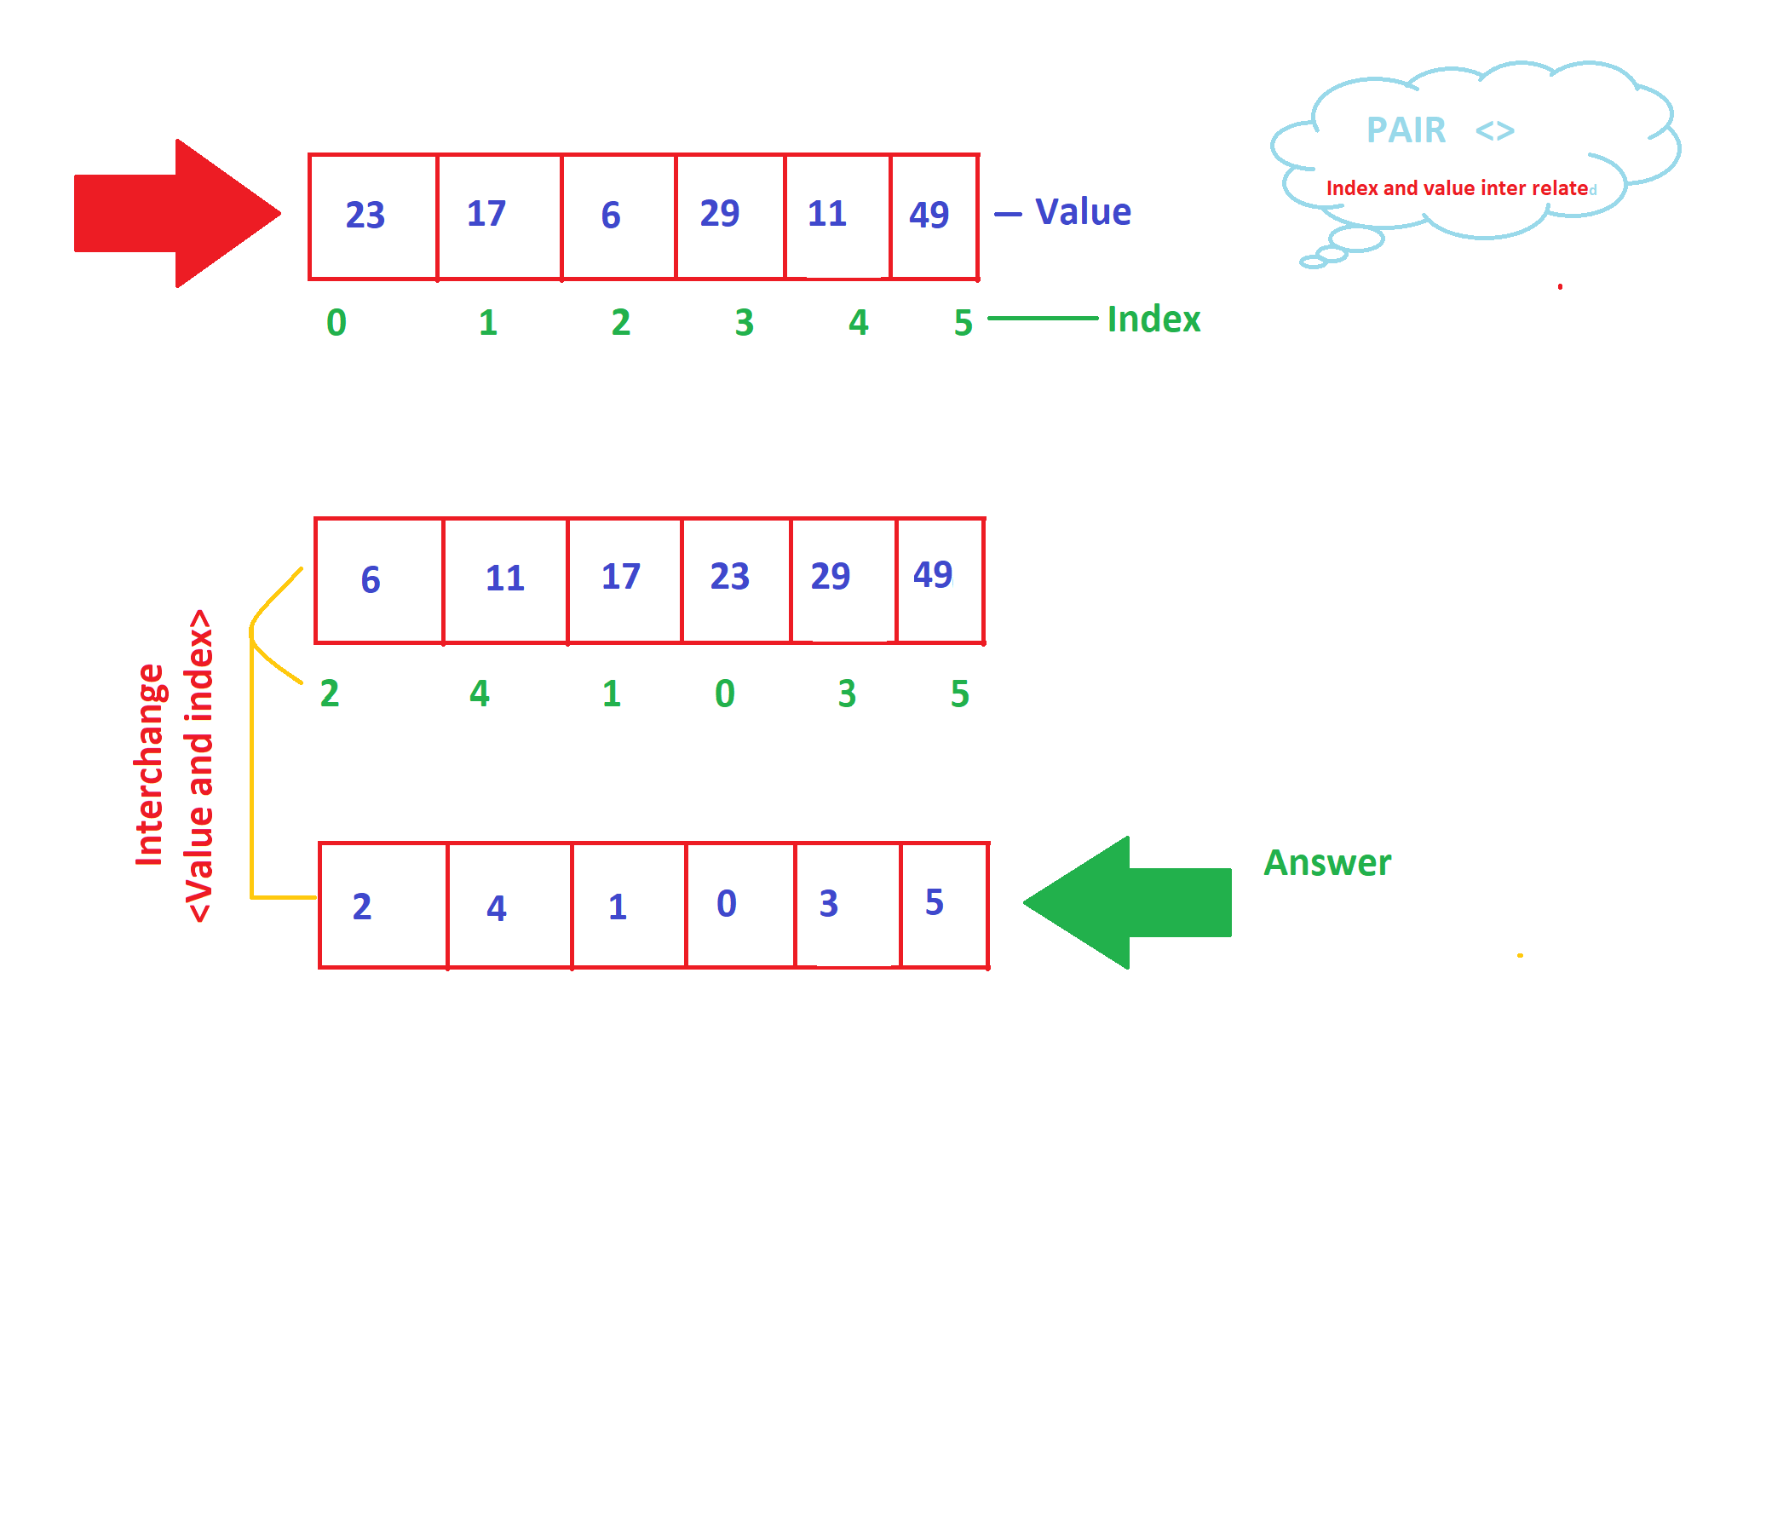

Code:
//Application of pair and vector
//Sorting Array as per value and then change the value with related indexes.
//Here array and it's value both are inter related,so during sorting as per value need to store related index also.
//HEre concept of pair and vector is very useful.

#include<iostream>
#include <bits/stdc++.h> //Required for sorting
#include<vector>

using namespace std;

//-------------------------------------------------------------------------------
//Our own function
bool compare_array_val(pair<int,int>p1,pair<int,int>p2)
{
return(p1.first < p2.first);
}
//-------------------------------------------------------------------------------

int main()
{
//-------------------------------------------------------------------------------
//Fixed Array
int array[] = {23,17,6,29,11,49};
vector< pair<int,int> > v; //Like 2D array but here every elemnt have significant value with it's pair element

//Store value and index as a pair of vector
for(int a = 0;a < (sizeof(array) / sizeof(array[0])); a++)
{
//make pair is inbuilt function
v.push_back(make_pair(array[a],a));
//We are storing first value and second index
}
cout << endl << "Before sorting : " << endl;
vector< pair<int , int> > :: iterator it;
for(it=v.begin();it != v.end(); it++)
{
cout << endl << "Element : " << it->first << " Index : " << it->second;
}

//-------------------------------------------------------------------------------

//-------------------------------------------------------------------------------
//Sort as per value
sort(v.begin(),v.end(),compare_array_val);
//-------------------------------------------------------------------------------

//-------------------------------------------------------------------------------
//print array
//After sorting element and related index
vector < pair<int,int> > :: iterator itr;
cout<<endl<<"After sorting : "<<endl;
for(itr = v.begin();itr != v.end(); itr++)
{
cout<< endl << "Element : " << itr->first << " at index : " << itr->second;
}
//-------------------------------------------------------------------------------

//-------------------------------------------------------------------------------
//Interchange with index
for(itr = v.begin();itr != v.end(); itr++)
{
int temp = itr->first;
itr->first = itr->second;
itr->second = temp;
}
//-------------------------------------------------------------------------------

//-------------------------------------------------------------------------------
cout << endl << "After interchange :"<<endl;
for(itr = v.begin();itr != v.end(); itr++)
{
cout<< endl << "Element : " << itr->first << " at index : " << itr->second;
}
//-------------------------------------------------------------------------------

return 0;
}

